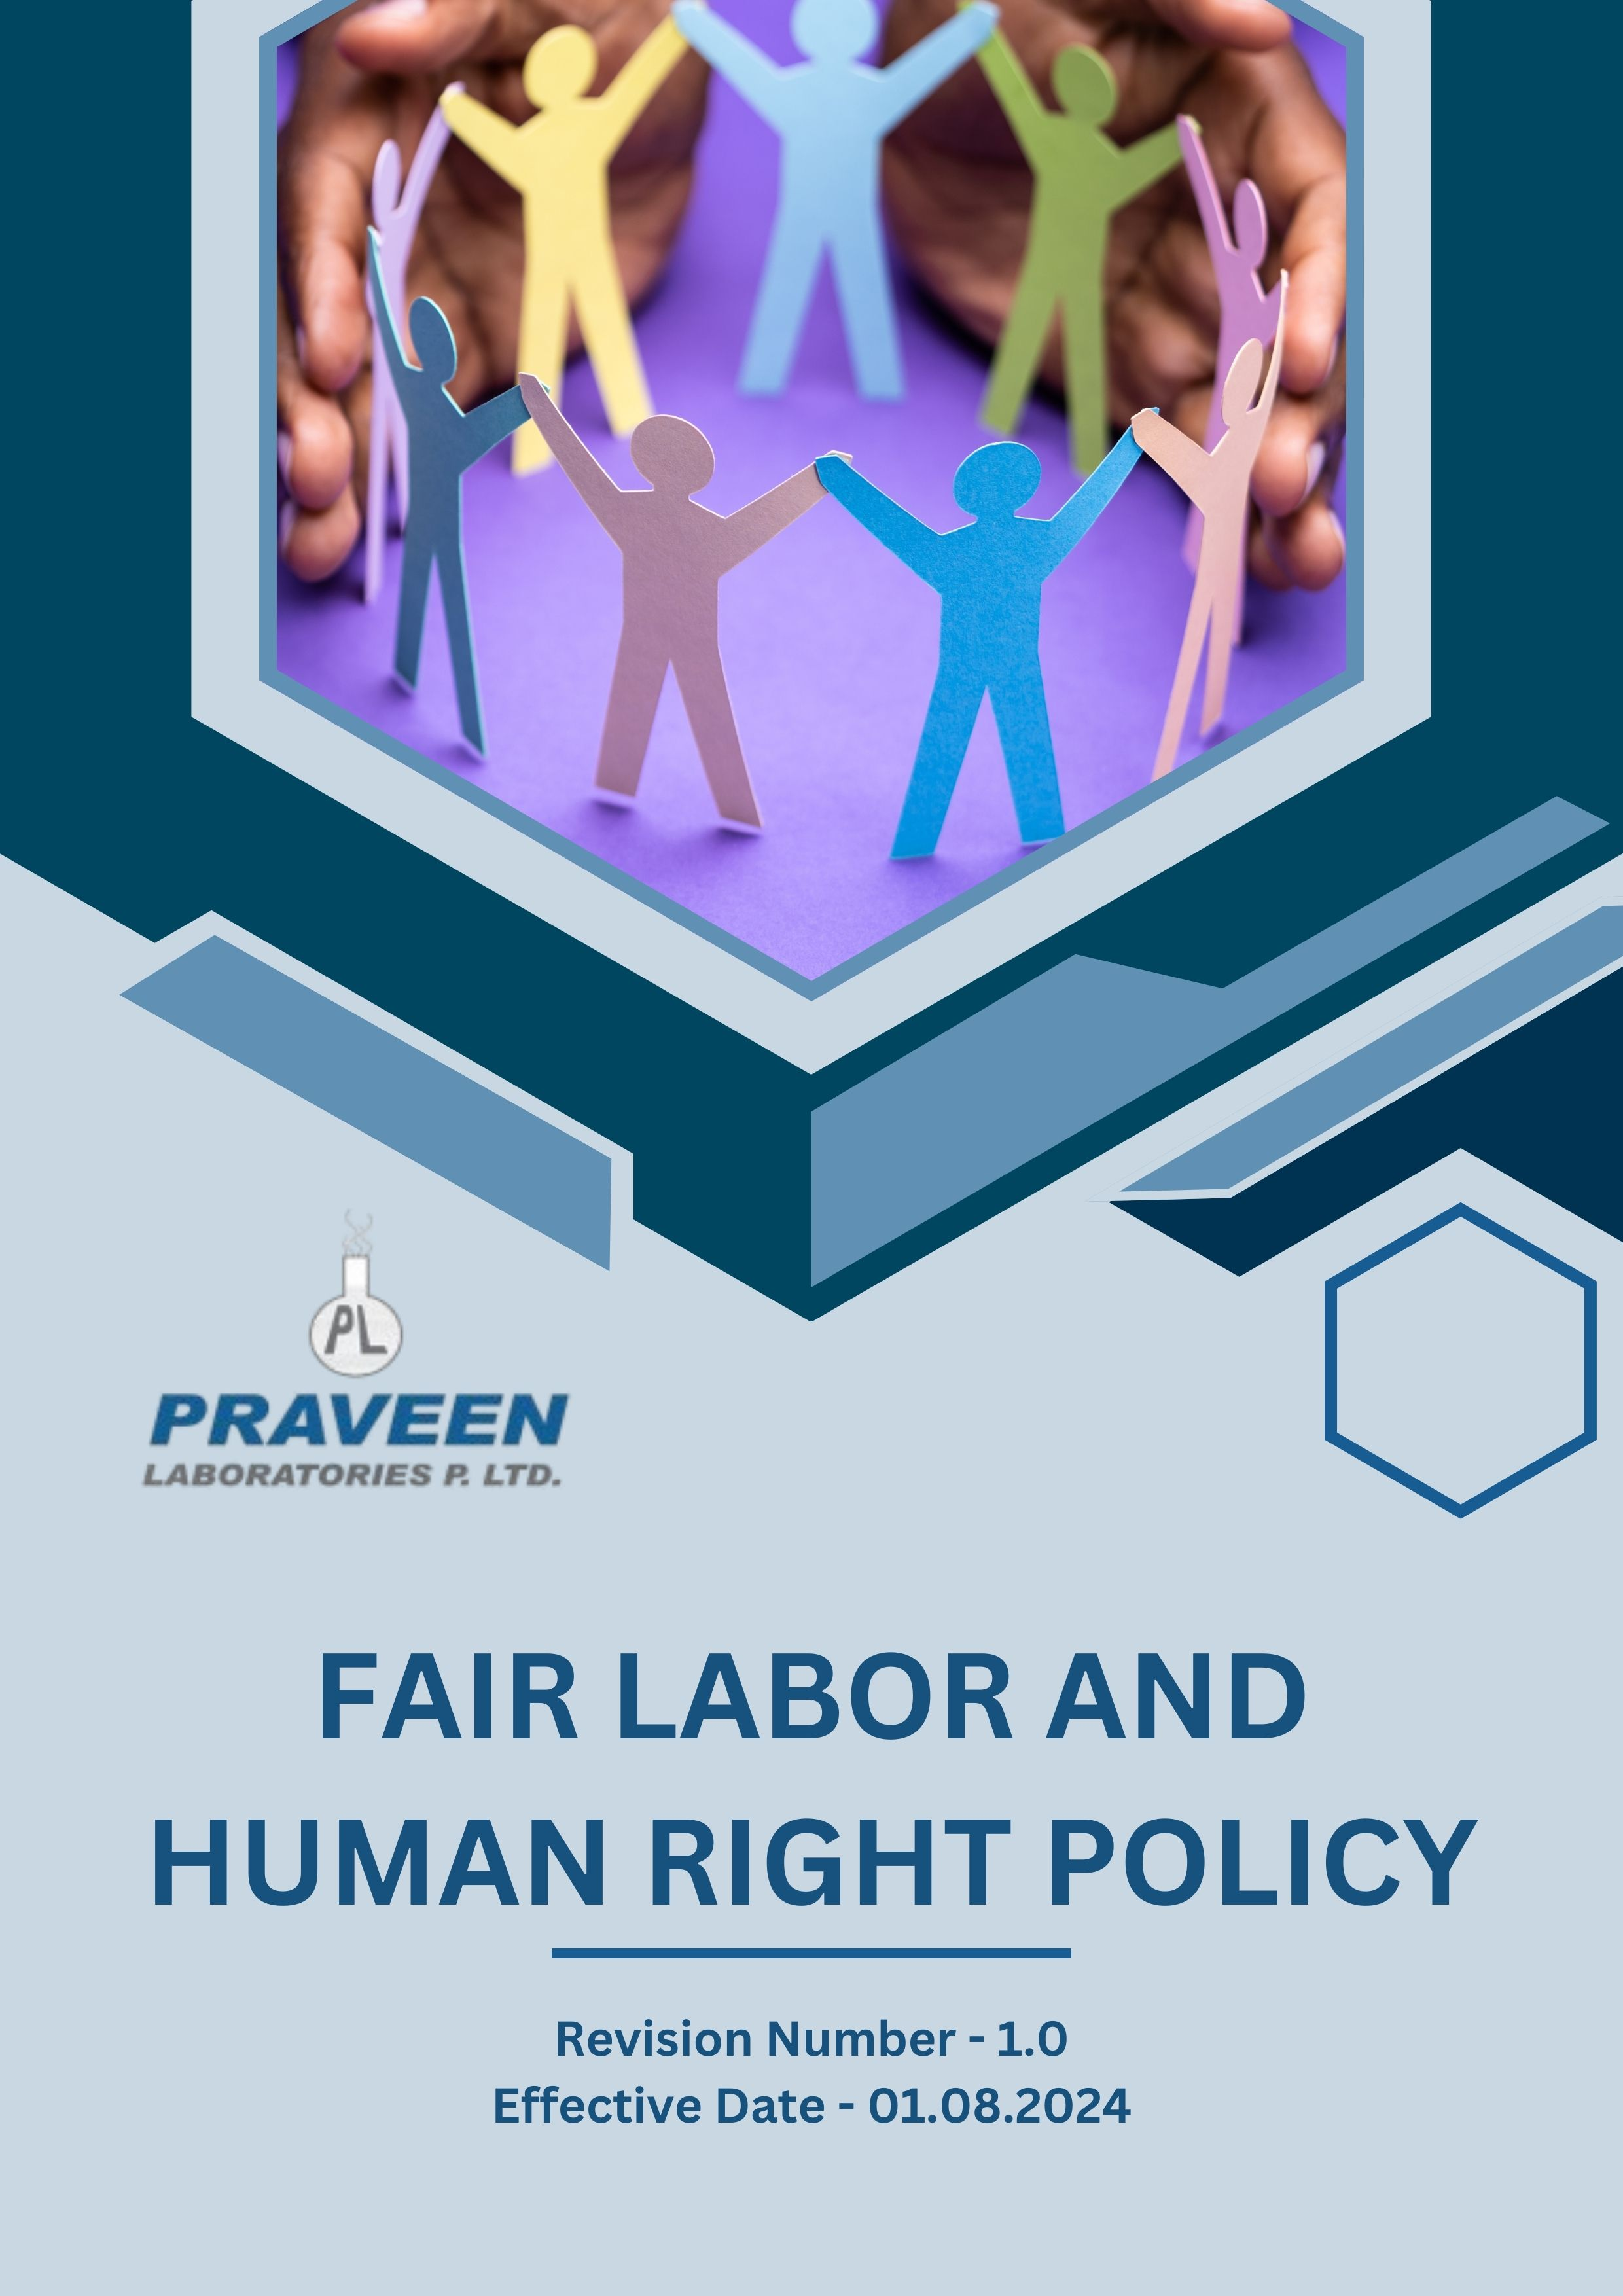

Table Of Contents

1. Overview 3
2. The PRAVEEN LABORATORIES PVT. LTD. Strategy 3
3. Applicability 3
4. Primary Focus area 4
5. Journey to Fundamental Rights: A PRAVEEN LABORATORIES PVT. LTD. Commitment: 6
6. Responsibility of this Policy 8
7. Governance 9
8. Reporting Section 9
9. Covered SDGs 10
10. Review Mechanism 10
11. Employee Acknowledgement Form: Fair Labor and Human Rights Policy 11

Overview
PRAVEEN LABORATORIES PVT. LTD. is committed to upholding the highest standards of labor and human rights in all aspects of its operations. We recognize that a strong labor and human rights framework is essential for fostering a positive and inclusive work environment, ensuring fair treatment of employees, and promoting ethical business practices across our supply chain. We believe that respect for human rights is a fundamental responsibility and a key component of sustainable business growth. By embedding ethical labor practices within our corporate culture, we not only protect the rights of our employees but also contribute to the broader global movement for social justice and human dignity.

The PRAVEEN LABORATORIES PVT. LTD. Strategy
We establish our goals on an annual basis, ensuring that we not only develop the essential capabilities required but also allocate the appropriate resources necessary to effectively implement this policy. Our approach is around fostering innovation and enhancing operational efficiency, all while aligning the supply chain of PRAVEEN LABORATORIES PVT. LTD. with the overarching objectives of this policy. Furthermore, our commitment transcends mere adherence to labor laws, we are dedicated to cultivating a workplace environment where diversity is not only recognized but celebrated. We actively work to eliminate any form of discrimination, empowering our employees to unlock their full potential and thrive in a supportive and inclusive atmosphere.

Applicability
This policy applies to all employees, stakeholders, contractors, partners, customers, contractual workers, and anyone acting on behalf of following sites:
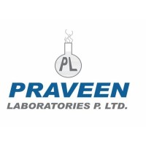 | Praveen Laboratories Pvt. Ltd.
 | Office Address: 720, Golden Point, Falsawadi, Ring Road, Surat-395003, Gujarat, India
 | Factory Address: BlockNo.206, Village: Jolwa, Taluka: Palsana, Dist: Surat‐394305, Gujarat, India
 | http://www.praveenlabs.com/

Primary Focus area
- Compliance with National & International Standards
PRAVEEN LABORATORIES PVT. LTD. adheres to the principles outlined in the National and International frameworks on Business and Human Rights. We also align our practices with the United Nations Global Compact (UNGC) and other sustainability charters where applicable.

- Workplace Health and Safety
- Ensure proper ergonomics in workstations and provide necessary personal protective equipment (PPE) for all employees.
- Maintain a workplace free from hazards by implementing regular risk assessments and safety audits.
- Provide ongoing safety training to all employees, ensuring they understand and adhere to workplace safety protocols.

- Working Environment
- Promote a healthy balance between professional and personal life by encouraging flexible work arrangements where applicable.
- Establish open communication channels to ensure employees feel heard, valued, and supported in their professional growth.
- Ensure that all employees receive fair wages aligned with industry standards and local labor laws.

- Career Development and Training
- Ensure a transparent and merit-based recruitment process that promotes diversity, equity, and inclusion.
- Establish a fair and objective performance evaluation system that recognizes achievements and identifies areas for improvement.
- Offer continuous learning opportunities, including technical training, leadership programs, and soft skills development.

- Child Labor, Forced Labor and Human Trafficking
- Ensure strict compliance with national and international labor laws, including the minimum legal working age requirements.
- Prohibit any form of forced, bonded, or involuntary labor within Praveen Laboratories Pvt. Ltd. and its business operations.
- Conduct risk assessments to identify and mitigate potential risks related to human trafficking in our operations and supply chains.

- Diversity, Equity, and Inclusion
- Maintain a zero-tolerance policy for discrimination, harassment, and any form of physical, psychological, or verbal abuse in the workplace.
- Ensure that hiring, promotions, compensation, and professional development opportunities are based on merit, skills, and qualifications.
- Regularly assess workplace policies and practices to ensure they align with the principles of diversity, equity, and inclusion.

- External Stakeholder Human Rights
- Ensure that all suppliers, contractors, and business partners adhere to ethical labor practices and human rights standards.
- Support community development initiatives that promote education, health, and sustainable livelihoods.

- Fair Wage and Compensation
- Ensuring that all employees receive living wages that exceed the legal minimum is a fundamental part of fostering a fair and equitable workplace.
- Each position should be compensated fairly based on its responsibilities, required skills, and market conditions, rather than on outdated perceptions or biases.
- To effectively promote wage equity across the board, implementing transparent salary structures is key.

- Community Engagement
- Ensure employees have the right to freely associate and elect representatives without fear of discrimination or retaliation.
- Recognize and respect the right of employees to engage in collective bargaining to negotiate fair wages, benefits, and working conditions.

Journey to Fundamental Rights: A PRAVEEN LABORATORIES PVT. LTD. Commitment:
Considering calendar year 2022 as the Baseline year for measuring progress and achievements in our Labor and Human Rights initiatives.

- Workplace Health and Safety:
- We uphold a strict policy of zero tolerance regarding the Total Recordable Incident Rate (TRIR), emphasizing our commitment to maintaining the highest safety standards in the workplace.
- We guarantee that 100% employees complete mandatory health and safety training programs each year, ensuring full compliance by the year 2026.
- We intend to ensure that 100% of employees in high-risk areas have access to and properly use Personal Protective Equipment (PPE) by 2026.
- We plan to perform safety audits across all facilities, aiming for a 100% completion rate each year by 2026.

- Working Environment:
- We strive to achieve an employee satisfaction score of 80% or higher in annual surveys by the end of 2026.
- We plan to implement flexible work arrangements for at least 60% of eligible positions by 2026.
- We intend to achieve that 90% of employees participate in professional development programs annually by 2026.
- We aim to provide comprehensive health insurance coverage to 100% of our employees by 2026, ensuring access to quality healthcare and financial security.

- Community Engagement:
- We strive to achieve a 90% participation rate in annual employee engagement surveys by the end of 2026.
- We plan to resolve 95% of employee grievances within 30 days by 2026.
- We intend to ensure that 100% of eligible employees are informed about their rights to union representation by 2026.

- Career Development and Training:
- We seek to ensure that each employee completes a minimum of 20 hours of job-specific training annually by the end of 2026.
- We plan to enrol 15% of employees in leadership development programs by 2026 to cultivate internal talent for managerial positions.
- We intend to achieve a 95% certification rate for employees undergoing professional development courses by 2026.
- We strive to attain an 85% satisfaction rate in post-training evaluations by 2026, ensuring the effectiveness and relevance of training programs.

- Child Labor, Forced Labor, and Human Trafficking:
- We are committed to ensuring that we have successfully eradicated any instances of child labor, forced labor, or human trafficking within our operations and supply chains.
- We plan to provide training on ethical labor practices to 100% of employees and suppliers by 2026 to prevent labor rights violations.
- We plan to partner with NGOs to strengthen anti-trafficking efforts by 2026.

- Diversity, Equity, and Inclusion:
- We strive to achieve 15% representation of women and 10% representation of underrepresented minorities in leadership positions by 2026.
- We plan to allocate 20% of our procurement budget to minority-owned and women-owned suppliers by 2026.
- We intend to establish and support at least three Employee Resource Groups (ERGs) by 2026, focusing on various aspects of diversity, to promote inclusivity and provide support networks within the company.
- We ensure 100% of employees complete annual Diversity, Equity, and Inclusion (DEI) training programs, with a focus on unconscious bias, cultural competency, and inclusive practices, by 2026.

- Fair Wage and Compensation
- We intend to achieve 100% gender pay equity across all job categories by 2026.
- Provide 100% of employees with comprehensive health insurance covering immediate family members by 2026.

- External Stakeholder Human Rights:
- We strive to implement human rights training programs for 90% of suppliers by 2026 to promote awareness and compliance throughout our supply chain.
- We plan to ensure that 100% of external stakeholders, including suppliers and contractors, have access to effective grievance mechanisms by 2026 to report human rights concerns.
- We intend to achieve 95% compliance with our Supplier Code of Conduct among all suppliers by 2026, emphasizing human rights and ethical practices.

Responsibility of this Policy
- Managing Director:
- Ensuring that labor and human rights principles are embedded into corporate governance and business strategy.
- Conducting annual reviews of the policy’s effectiveness and ensuring the publication of progress reports in sustainability disclosures.

- Chief Human Resources Officer (CHRO):
- Leading the overall strategy for labor and human rights across the organization and ensuring alignment with global sustainability frameworks and best practices.
- Reports directly to the Managing Director and provides regular updates to the Board of Directors.

- Human Resource Department Head:
- Conducting regular assessments to ensure compliance with labor and human rights standards.
- Encouraging a culture of ethical labor practices among employees.

- Compliance Manager:
- Conducting audits and risk assessments related to labor and human rights.
- Investigating reported violations and ensuring corrective actions are taken.
- Maintaining comprehensive records of compliance initiatives and reports.

- Employees:
- Adhering to the principles outlined in this policy and actively participating in training programs and fostering an inclusive workplace.
- Reporting any labor rights violations or unethical practices through designated channels.

Governance
Praveen Laboratories Pvt. Ltd. ensures strong governance to uphold labor and human rights across all operations. Senior leadership integrates fair labor practices into corporate strategy, while the CHRO, HR Head, and Compliance Manager oversee implementation, audits, and policy adherence. Regular assessments, audits, and employee engagement help maintain transparency and accountability. A grievance mechanism allows confidential reporting of violations, ensuring prompt corrective action. Supplier compliance is monitored through audits and reporting. This governance framework fosters ethical labor standards and continuous improvement.

Reporting Section
- Internal Reporting:
- Annual Labor and Human Rights Dashboard:
- The Chief Human Resources Officer (CHRO) presents a comprehensive labor and human rights dashboard to senior management and the Board.
- The dashboard highlights progress towards annual labor and human rights targets, emerging trends, and areas needing attention.
  - Workplace Incident Reporting:
- A dedicated system for employees to report labor rights violations, discrimination, harassment, or unsafe working conditions.
- The Compliance Manager investigates all reports and ensures corrective actions are implemented in a timely manner.

- External Reporting:
- Annual Public Reporting:
- External reporting is conducted annually to communicate our labor and human rights performance to stakeholders, including employees, customers, investors, and regulatory bodies.
- Reports are prepared in accordance with internationally recognized standards such as the United Nations Guiding Principles on Business and Human Rights (UNGPs) and Global Reporting Initiative (GRI) guidelines.
- Supplier Compliance Reporting:
- We require suppliers to submit annual reports on their labor and human rights compliance, including any corrective actions taken.
- Audits and third-party assessments are conducted to verify compliance with our Supplier Code of Conduct.
- Stakeholder Engagement:
- Employee and Supplier Engagement:
- We actively engage with employees, suppliers, and other stakeholders to gather feedback, address concerns, and foster transparency in our labor and human rights practices.
- Regular stakeholder meetings and surveys help assess the effectiveness of our initiatives and inform continuous improvement efforts.
- Grievance Mechanisms:
- A formal grievance mechanism is in place to ensure employees and external stakeholders can report violations confidentially and without fear of retaliation.
- Grievance reports are reviewed by the Compliance Manager and addressed according to established procedures.

Covered SDGs
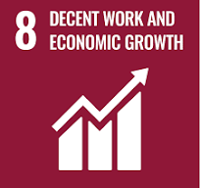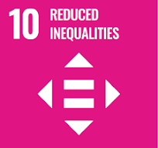

Review Mechanism
- Policy Review and Update:
- The Chief Human Resource Officer reviews this policy annually to ensure alignment with changing regulatory requirements, industry best practices, and stakeholder expectations.
- Company can also change or review policy if any necessary changes is required.
- Updates to the policy are communicated internally, and relevant training is provided to ensure awareness and compliance with labor and human rights standards.

(Signature)
Approved By: General Manager
Next Review Date: 31-07-2025

Employee Acknowledgement Form: Fair Labor and Human Rights Policy

I acknowledge that I have received, read, and understood PRAVEEN LABORATORIES PVT. LTD. Fair Labor and Human Rights Policy. I am aware of the company's commitment to upholding fair labor practices, promoting a diverse and inclusive workplace, and ensuring the protection of human rights across all operations and supply chains.
I understand my role in supporting this policy, including complying with all applicable labor laws and regulations, respecting human rights, and fostering a safe and inclusive work environment. I agree to adhere to ethical labor practices in my daily work, report any labor or human rights concerns, and contribute ideas for continuous improvement.
By signing below, I confirm my commitment to upholding PRAVEEN LABORATORIES PVT. LTD. Fair Labor and Human Rights Policy and supporting the company’s efforts in maintaining ethical labor practices.

Employee Name: ______________________
Date: _______________
Employee Signature: ____________________

